Front End Practical Exercise

Brief: Create an animated fundraising totaliser
Time allowed: 1 hour (or 1 hour 15 minutes if completing remotely)

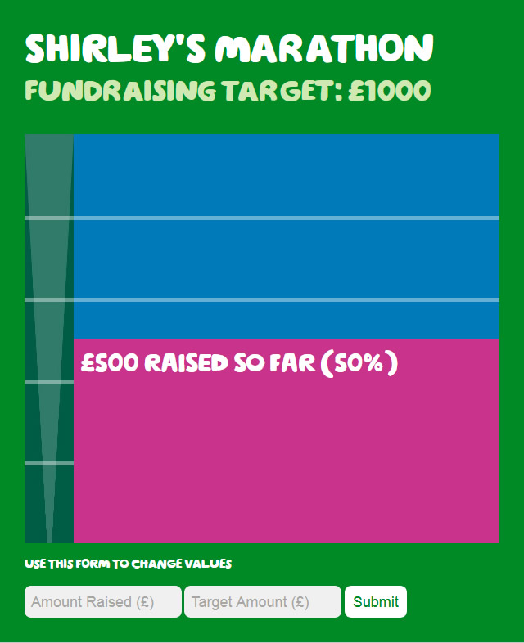

The aim of this exercise is to create a working fundraising totaliser that will show how much a fundraiser has raised against their target fundraising amount when the page is loaded. A similar totaliser is used on JustGiving pages e.g. https://www.justgiving.com/fundraising/joe-cicero1. Some basic UI has been provided.

What we’d like you to do is animate the pink area of the totaliser to the correct height to present how much has been raised against the target amount. On a real site the data would be provided by a service or from the back end so you can use the form provided as a mechanism to populate the values. As an example, we have set it up with a £1000 target with £500 raised so far. The totaliser should be dynamic and should work for any combination of values up to the target amount.

If you have time, use the divider spans to dynamically create intervals on the totaliser. As an example 4 of these have been added to signify divisions of 200 on the totaliser because the fundraising target is 1000. Feel free to add these at your own intervals.

jQuery is provided and can be used if you wish. There is no bearing on how much jQuery is used vs vanilla JavaScript, use whatever works best.

Feel free to change any of the HTML, CSS and class names as you wish. The totaliser will need to work in Chrome on the desktop. No other support is required.

Good luck!

